BADMINTON STUDY GUIDE

I. HISTORY
Badminton originated from a game in India called Poona. British army officers stationed in India brought the games to England around 1860. The name “Badminton” is said to be derived from an English duke’s country estate called Badminton House, where the duke entertained his guests with rounds of Poona. The guests showed their appreciation by adding a few rules and renaming the game “Badminton”. The first national championships were held in 1898 in England. During this time, Badminton was introduced in Canada and from there to the US.

II. RULES
Scoring System
- A match consists of the best of 3 games of 21 points.
- Every time there is a serve – there is a point scored.
- The side winning a rally adds a point to its score.
- At 20 all, the side which gains a 2 point lead first, wins that game.
- At 29 all, the side scoring the 30th point, wins that game.
- The side winning a game serves first in the next game.
Interval and Change of Ends
- When the leading score reaches 11 points, players have a 60 second interval.
- A 2 minute interval between each game is allowed.
- In the third game, players change ends when the leading score reaches 11 points.
Singles
- At the beginning of the game (0-0) and when the server’s score is even, the server serves from the right service court. When the server’s score is odd, the server serves from the left service court.
- If the server wins a rally, the server scores a point and then serves again from the alternate service court.
- If the receiver wins a rally, the receiver scores a point and becomes the new server. They serve from the appropriate service court – left if their score is odd, and right if it is even.
Doubles
- A side has only one ‘service’.
- The service passes consecutively to the players as shown in the diagram.
- At the beginning of the game and when the score is even, the server serves from the right service court. When it is odd, the server serves from the left court.
- If the serving side wins a rally, the serving side scores a point and the same server serves again from the alternate service court.
- If the receiving side wins a rally, the receiving side scores a point. The receiving side becomes the new serving side.
- The players do not change their respective service courts until they win a point when their side is serving.
If players commit an error in the service court, the error is corrected when the mistake is discovered.

III. THE SIX CLASSIC SHOTS
1. Serve – hit that begins play; pinch the skirt/feathers of the birdie and hit it from below the waist
2. High Clear – high, deep hit to the back of opponent’s court – also called a lob
3. Overhead/Underhand Drop Shot
4. Slam – fast downward shot that is close to the net. The opponent can not make a return shot.
5. Drive – hard, overhead hit that goes down toward the middle to back of the opponent’s court
6. Hairpin – underhand shot from below and close to the net that goes up and over the net

IV. TERMINOLOGY

Ace – one point, unit of scoring, non-returnable serve
Alley – extension of the court by ½ feet on both sides
Fault – a violation of the playing rules; either in serving, receiving, or during play
Rally – exchange of shots while shuttle is in play

Backcourt – back third of the court, in the area of the back boundary line
Kill/Slam – fast downward shot that cannot be returned, a “put away”, must be close to the net to hit
Drive – hard-hit overhand shot that forces the shuttle sharply downward, hit from middle to deep of your court
High Clear – a shot hit deep to the opponent’s side – a lob
Drop Shot – a quick wrist and forearm rotation that surprises the opponent by exchanging an apparent soft shot into a faster passing one
Hairpin net shot – shot made from below the and very close to the net and with the shuttle rising, just clearing the net, and then dropping sharply down the other side

Let – a legitimate cessation (stop) of play to allow a rally to be replayed
Forecourt – front third of the court, between the net and the short service line
Shuttlecock – Official name of the object that the players must hit. Composed of 16 goose feathers attached to a cork base covered with leather. Synthetic shuttles are also used, may also be called a birdie
Short Service Line – the line 6 ½ feet from the net which a serve must reach to be legal

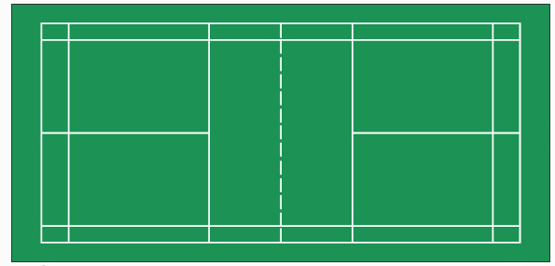
Right Service Area (Singles -even score)
Left Service Area
(Singles - odd score)
Short Service Line

